AIR QUALITY MONITORING SYSTEM

# 1. INTRODUCTION:

Air quality monitoring is a critical process that involves the continuous measurement and assessment of various pollutants and contaminants present in the Earth's atmosphere. It is essential for understanding and managing the quality of the air we breathe, as well as for safeguarding public health, protecting the environment.

The quality of the air we breathe is of paramount importance because it directly impacts human health, ecosystems, and the overall well-being of our planet. Air pollution can result from natural sources, such as wildfires and volcanic eruptions, but it is predominantly caused by human activities, including industrial processes, transportation, and energy production.

Air quality monitoring involves the use of specialized instruments and sensors strategically placed in various locations, including urban areas, industrial zones, and natural environments, to continuously measure pollutant concentrations and other relevant air quality parameters. These measurements are typically collected in real-time or at regular intervals and are transmitted to central databases for

analysis and reporting.

# 2 .OBJECTIVE:

The primary objectives of air quality monitoring are to assess, understand, and manage the quality of the air in a specific area or region. These objectives are crucial for various reasons, including public health protection, environmental conservation, regulatory compliance, research, and informed decision-making. Here are the key objectives of air quality monitoring:

**Public Health Protection:** One of the foremost objectives of air quality monitoring is to safeguard public health. It helps identify and quantify the levels of harmful pollutants in the air, such as particulate matter (PM), ground-level ozone (O3), nitrogen dioxide (NO2), and carbon monoxide (CO). Monitoring data can be used to issue warnings and advisories to the public when air quality reaches levels that could pose health risks, particularly to vulnerable populations like children, the elderly, and individuals with pre-existing respiratory conditions.

**Environmental Conservation**: Monitoring air quality is essential for assessing the impact of air pollutants on the environment. It helps evaluate the effects of pollution on ecosystems, including damage to vegetation, contamination of water bodies, and harm to wildlife. By understanding these impacts, measures can be taken to protect and preserve natural environments.

**Regulatory Compliance**: Governments and regulatory agencies establish air quality standards and regulations to limit the concentration of specific pollutants in the atmosphere. Air quality monitoring is used to determine whether these standards are being met and to enforce compliance. Non-compliance may result in penalties and the implementation of pollution control measures.

**Research and Policy Development**: Air quality data collected through monitoring programs is invaluable for scientific research and policy development. Researchers use this data to study trends, correlations, and the effects of air pollution on human health and the environment. Policymakers rely on this information to formulate evidence-based policies and regulations aimed at improving air quality and reducing the negative impacts of pollution.

**Source Identification and Control**: Monitoring can help identify the sources of air pollution in a given area. By pinpointing the origins of pollutants, authorities can implement targeted control measures to reduce emissions from specific industries, transportation sectors, or other pollution sources. This can be a vital step in improving air quality.

**Emergency Response**: Air quality monitoring systems are crucial during environmental emergencies, such as wildfires, industrial accidents, or chemical spills. Real-time monitoring data can provide essential information to emergency responders and the public, enabling swift action to protect health and safety.

**Public Awareness and Education**: Sharing air quality information with the public promotes awareness and encourages individuals and communities to take actions to reduce their contributions to air pollution.

# METHODOLOGY:

Air quality monitoring involves a systematic methodology for the measurement andassessment of various pollutants and air quality parameters in the atmosphere. The methodology can vary depending on the specific objectives of the monitoring program, the pollutants of interest, and the available resources. However, the following steps generally represent a typical methodology for air quality monitoring:

# Objective Definition:

Clearly define the objectives of the air quality monitoring program. Determine the specificpollutants or parameters to be measured and the purpose of the monitoring (e.g., public health protection, regulatory compliance, research).

## Site Selection:

Identify monitoring locations based on the objectives and the expected sources of pollution. Locations may include urban areas, industrial zones, residential neighborhoods, and natural environments.

Ensure that monitoring sites are representative of the area being studied and follow established guidelines for site selection.

## Instrumentation Selection:

Choose appropriate monitoring instruments and sensors for measuring the target pollutants and air quality parameters.

## Common instruments include:

Particulate matter (PM) samplers

Gas analyzers for pollutants like ozone (O3), nitrogen dioxide (NO2), sulfur dioxide (SO2), andcarbon monoxide (CO)

Meteorological instruments (e.g., anemometers, temperature and humidity sensors)Volatile organic compound (VOC) analyzers

Data loggers for recording measurements

Ensure that the selected instruments meet regulatory standards and have appropriateaccuracy and precision.

**Calibration and Quality Assurance:**Calibrate monitoring instruments regularly to ensureaccuracy and reliability of measurements.

Implement quality assurance and quality control procedures to identify and correct anymeasurement errors.

**Data Collection**:Install monitoring equipment at selected sites and ensure they are properlymaintained.Collect continuous or periodic measurements of pollutants and air quality parameters. Data can be collected in real- time or through discrete sampling.

**Data Transmission and Storage:**Transmit monitoring data to a central database or control center for storage and analysis. Modern systems often use remote data transmission for real-time monitoring.Store data securely and maintain records for future reference and analysis.

**Data Analysis:**Analyze monitoring data to assess air quality, identify trends, and compareresults to air quality standards and regulations.Use statistical methods and modeling to interpret data and assess the impact of pollutionsources on air quality.

**Reporting and Communication:**Generate regular air quality reports and share informationwith relevant authorities, the public, and stakeholders.Provide real-time data to the public through websites, mobile apps, or other communicationchannels to inform residents about current air quality conditions and health advisories.

**Regulatory Compliance:**If the monitoring program is conducted for regulatory purposes, ensure that data are used to assess compliance with air quality standards and regulations.Non-compliance may trigger enforcement actions.

**Emergency Response:**During environmental emergencies (e.g., wildfires, industrial accidents), use real-time monitoring data to provide timely warnings and support emergencyresponse efforts.

**Data Management and Archiving**:Establish long-term data management and archiving procedures to maintain a historical record of air quality measurements. This data can bevaluable for trend analysis and policy evaluation.

**Review and Adaptation**:Periodically review the monitoring program to assess its effectiveness and relevance. Make necessary adjustments to instrumentation, site locations,or objectives based on changing conditions and priorities.

**Public Engagement:**Engage with the public and stakeholders to foster awareness of air quality issues and provide information on actions individuals and communities can take toreduce air pollution.

# COMPONENTS

* + **Arduino Board**

# LCD Display

* + **MQ2 Gas Sensor**

# Buzzer

* + **Breadboard**

# Jumper wire

1. 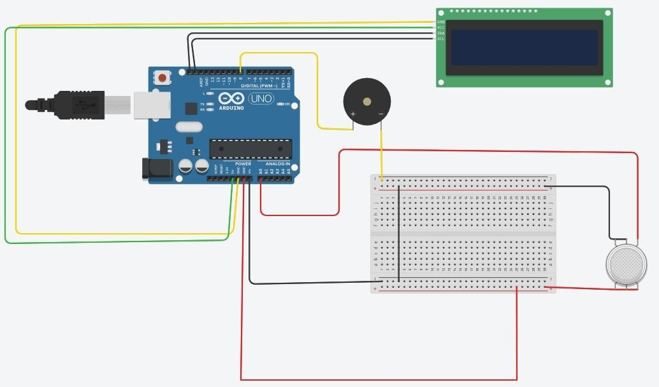**CIRCUIT DIAGRAM:**

# ADVANTAGES:

**Early Warning of Health Risks**: Real-time air quality monitoring provides early warnings during environmental emergencies, such as wildfires, industrial accidents, or chemical spills. This allows for rapid response and evacuation if necessary, minimizing health risks.

**Environmental Conservation**: Monitoring air quality helps assess the impact of air pollutants on ecosystems, including damage to vegetation, contamination of water bodies, and harm to wildlife. This information is critical for environmental conservation and biodiversity preservation.

**Regulatory Compliance**: Monitoring is essential for ensuring compliance with air quality standards and regulations set by governmental agencies. It holds industries and other pollution sources accountable for their emissions, helping to reduce pollution and protect public health.

**Scientific Research**: Air quality monitoring data are invaluable for scientific research. Researchers use this data to study trends, correlations, and the effects of air pollution on human health, ecosystems, and climate change. It contributes to a deeper understanding of the environment and supports evidence-based decision-making.

# APPLICATIONS:

**Health Alerts**: Real-time air quality monitoring provides information to the public about current air quality conditions, especially during periods of poor air quality due to pollution or environmental events like wildfires. This information helps individuals take precautions to minimize health risks.

Regulatory Compliance:

**Enforcement of Air Quality Standards**: Governments and regulatory agencies use air quality monitoring data to assess compliance with air quality standards and regulations. Non-compliance may result in penalties and the implementation of pollution control measures.

**Industrial Emissions Control**:Emission Monitoring: Industries utilize air quality monitoring to measure and control emissions of pollutants from their facilities. Monitoring helps them comply with environmental regulations and reduce their environmental impact.

Transportation Planning:

**Traffic Management**: Air quality data help urban planners and transportation authorities manage traffic flow and reduce congestion, which can lead to lower emissions from vehicles.

Environmental Conservation:

**Ecosystem Protection**: Monitoring air quality helps assess the impact of air pollutants on ecosystems, including damage to vegetation, contamination of water bodies, and harm to wildlife. This information supports environmental conservation efforts.